### Philippine Logo.jpgNEWS RELEASE

*Philippine Mission to the United Nations*

556 Fifth Avenue, New York, N.Y. 10036 (212)764 -1300 www.un.int/philippine

**PH shares best practices on social protection and inclusion at the UN**

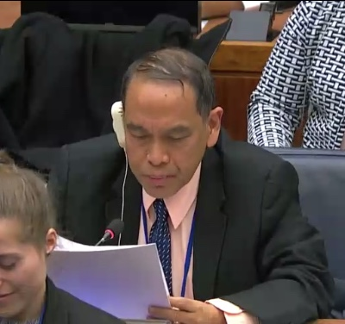

**12 February 2019, New York** – Philippine Finance Undersecretary Gil S. Beltran addressed representatives from Member States, UN agencies and civil society organizations at the 57th session of the Commission for Social Development during its General Discussion where he articulated PH policies on fiscal, wage and social protection to address inequalities and challenges to social protection.

“No development policy is sound that does not put the greatest number of people at the front and center. Wealth that is enjoyed only by the few is no better than poverty for its breeds inequality, fosters social exclusion and creates a divide that takes generations to close” Undersecretary Beltran said in his statement.

Undersecretary Beltran outlined the initiatives being undertaken by the government through the “Ambisyon 2040.” Among these initiatives are the Pantawid Pamilyang Pilipino Program (4Ps), the Philippine Youth Development Plan 2017-2022 and the social pension program for older persons.

The Commission for Social Development takes place from 11 to 21 February 2019 at the United Nations Headquarters in New York. The Commission is the advisory body responsible for social development pillar for global development. **END**