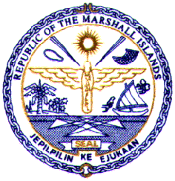
REPUBLIC OF THE MARSHALL ISLANDS

Statement by Ms. Rina Tareo
Permanent Mission of the Republic of the Marshall Islands
to the United Nations

Special Political and Decolonization Committee
Agenda Item 75: Effects of Atomic Radiation
18 October 2004

Mr. Chairman,

As this is my first time addressing the Committee this session, please accept my delegation’s congratulations to you and to the other members of the bureau for your election.

Mr. Chairman,

The subject matter of agenda item 75, the Effects of Atomic Radiation, is of the utmost concern for the people of the Marshall Islands. Between 1946 and 1958, the United States conducted a series of nuclear tests in the Marshall Islands, which included the detonation of 67 atomic and hydrogen bombs. In March this year, we commemorated the 50th anniversary of the Bravo test conducted at Bikini Atoll – a blast that was 1,000 times more powerful than the atomic bomb in Hiroshima. The fallout of that blast spread radioactive debris across our islands and today many of our people continue to suffer from long term health effects while others remain displaced from their homes due to ongoing contamination.

Mr. Chairman,

The Republic of the Marshall Islands is a strong supporter of the work of the United Nations Scientific Committee on the Effects of Atomic Radiation – a Committee whose studies and scientific investigations are of great value not only to us but to all the Member States of the United Nations.

My delegation would like to commend the Committee for its excellent work in providing the general public with access to its scientific findings, by making its publications available on the internet. Despite the Committee’s lack of adequate funding, the Committee has endeavored to continue to discharge the responsibilities entrusted to it.

We all recognize the importance of the Committee’s work. Therefore, we must ensure the provision of an adequate operating budget that will allow the Committee to fulfill its mandate. In this regard, my delegation strongly supports the Committee’s request for its funding to be strengthened to the level originally requested for 2004-2005.

Thank you Mr. Chairman.

