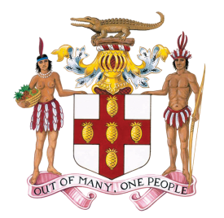

PERMANENT MISSION OF JAMAICA
TO THE UNITED NATIONS

STATEMENT BY

MRS. DIEDRE MILLS
DEPUTY PERMANENT REPRESENTATIVE
PERMANENT MISSION OF JAMAICA TO THE UNITED NATIONS

AT THE

THIRD SESSION OF THE PREPARATORY COMMITTEE ESTABLLISHED BY GENERAL ASSEMBLY RESOLUTION 69/292: DEVELOPMENT OF AN INTERNATIONAL LEGALLY BINDING INSTRUMENT UNDER THE UNITED NATIONS CONVENTION ON THE LAW OF THE SEA ON THE CONSERVATION AND SUSTAINABLE USE OF MARINE BIOLOGICAL DIVERSITY OF AREAS BEYOND NATIONAL JURISDICTION

INFORMAL WORKING GROUP ON CAPACITY-BUILDING
AND TRANSFER OF MARINE TECHNOLOGY

UNITED NATIONS, NEW YORK
31st MARCH 2017

Madam Facilitator,

My delegation joins others in congratulating you on your appointment as Facilitator and assures you of Jamaica’s full support.

I wish to align my brief intervention with that of the G77 and China, the AOSIS and, of course, CARICOM

I believe we have been engaged in a very useful discussion and that a lot of very interesting points have been made on which we can further reflect.

I wish to simply reiterate a point made by Singapore and Fiji on the issue of flexibility and for us to think more broadly in terms of the suite for ABMTs at our disposal. Our reading of some of the submissions that have been made, including in the context of the Chair’s Non-Paper, seem to discount this important fact. It is imperative, therefore, that we maintain a balanced focus in order that our treatment of the subject matter remains as comprehensive as possible, and is appropriately linked to the rest of the elements of the package.

