22 October 2020

Signing of the UN Sustainable Development Cooperation Framework 2021 - 2025
The United Nations in Eswatini and the Government of the Kingdom of Eswatini, signed the UN Sustainable Development Cooperation Framework 2021 - 2025.
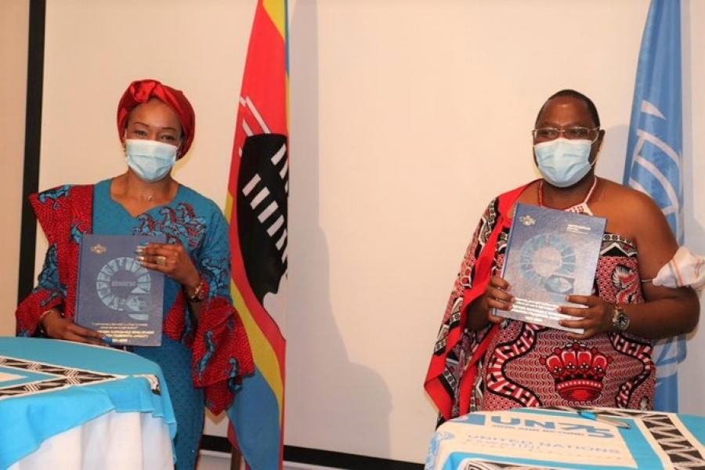
The UNRC Ms. Nathalie Ndongo-Seh and the Hon. Prime Minister Ambrose Dlamini Display the signed UNSDCF
On Thursday, the 22nd of October 2020 the United Nations Development System in Eswatini together with the Government of the Kingdom of Eswatini, signed the UN Sustainable Development Cooperation Framework (UNSDCF) for the period 2021 – 2025.
The United Nations Development Assistance Framework (UNDAF) for the 2016 – 2020 cycle will be coming to an end in December 2020 and the UN will transition to the new programme, the United Nations Sustainable Development Cooperation Framework (UNSDCF), for the 2021 – 2025 cycle.
The UNSDCF 2021 – 2025 represents the United Nations Development System’s collective offer to support the Kingdom of Eswatini in addressing its national development priorities, advancing the 2030 Agenda for Sustainable Development Goals, and transforming the lives of Emaswati in this last Decade of Action.
Speaking at the signing ceremony, the UN Resident Coordinator, Ms. Nathalie Ndongo-Seh stated that “the UNSDCF articulates the collective vision of the entire UN Development System in Eswatini, striving to deliver as one UN family with the Government of Eswatini to support “A prosperous, just and resilient Eswatini where no one is left behind”, in line with His Majesty’s Vision 2022, the National Development Plan and Strategic Road Map, Agenda 2030, Agenda 2063 and the voices of many Emaswati.
As an instrument for planning and implementing development programmes and activities at the country level, the UNSDCF 2021 – 2025 has been developed in close collaboration between the Government, the United Nations, development partners, civil society, academia, the private sector and community groups.
The Eswatini UNSDCF 2021 – 2025 will come into effect on the 1st of January 2021 and represents a major milestone for both the Kingdom of Eswatini and the United Nations at a time of great uncertainty and devastation as a result of COVID-19.
In celebration of this momentous occasion, Prime Minister Ambrose Mandvulo Dlamini expressed appreciation for the “52 years of impactful partnership between the Kingdom of Eswatini and the United Nations; a relationship that is built on trust, collaboration and commitment to the people of Eswatini.”
The signing ceremony saw the UNSDCF 2021 – 2025 being signed by the entire Cabinet and all Heads of UN Agencies, Funds and Programmes in Eswatini (16 in total), thereby committing individually and collectively to its implementation and successful delivery in the interest of the people of Eswatini.

